**CP Club 365 Days Challenge**

**Programming language – Python**

**Problem Statement**

<https://www.codechef.com/DSAPREP_01/problems/MONSTER1>

**Your Code**:

# 0x75Day of 0x365Days challenge

# VEDANT BHARAD

# 31-12-2022

# cook your dish here

t=int(input())

while t>0:

    H,X,Y=map(int,input().split())

    if Y>=X:

        print(0)

    else:

        print(1)

    t-=1

**Output (Screen Shot)**:

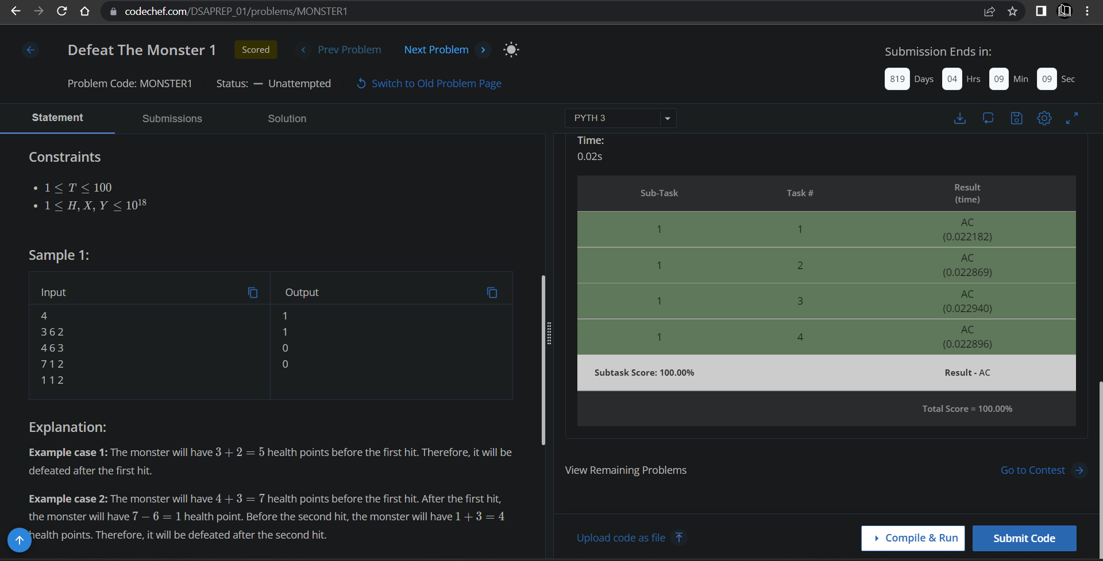

**Understanding about problem:**

* In this task there is three input H,X,Y.
* In this task I need to return the 1 or 0,if Y is grater then or equal to X then print 0 else print 1.

Note: If you can't understand the problem, feel free to contact us and we'll help you. Please don't copy and paste from anywhere.

ALL THE BEST

Team CP Club